1. Project Overview and Objective
🔹 Project Title:
Liquor Sales Analysis – Warehouse & Retail using Power BI
🔹 Project Objective:
The main objective of this project was to analyze liquor sales data from both warehouse and retail channels to understand sales trends, revenue contribution, and product performance, and to support better business decisions.

2. Data Sources
• Source Description: Open US data government platform. It is downloaded from the link
• Timeline: Data created on November 2020 and updated on September 2025
• Domain: Sales Analytics
3.🔹 Data Used:
- Sales Date
- Product / Brand Name
- Category (Beer, Wine, Spirits, etc.)
- Warehouse & Retail Outlet Details
- Quantity Sold
- Sales Amount

4.🔹 Tools & Technologies:
- Excel – Data cleaning, formatting, and validation
- Power BI – Data modeling, DAX measures, and dashboard creation

🔹 Key Steps Involved:
- Cleaned and prepared raw sales data using Excel
- Loaded data into Power BI
- Created relationships between tables (Date, Product, Sales)
- Built DAX measures for:
  - Total Sales
  - Quantity Sold
  - YTD Sales
  - Previous Year Sales
  - Sales Growth %

- Tools & Technologies
• Excel: Data cleaning, transformation, and Pivot Tables.
• Power BI: Data modelling, DAX calculations, visualization, and interactive dashboard creation.

- Designed interactive dashboards with slicers and KPIs
🔹 Key Insights:
- Identified top-selling brands and categories
- Compared warehouse vs retail sales performance
- Analyzed monthly and yearly sales trends
- Detected slow-moving products to improve inventory planning

7. Data Modelling and DAX (Power BI)
• Data Model: Established relationships between tables, defined cardinality, and created lookup
tables where necessary.

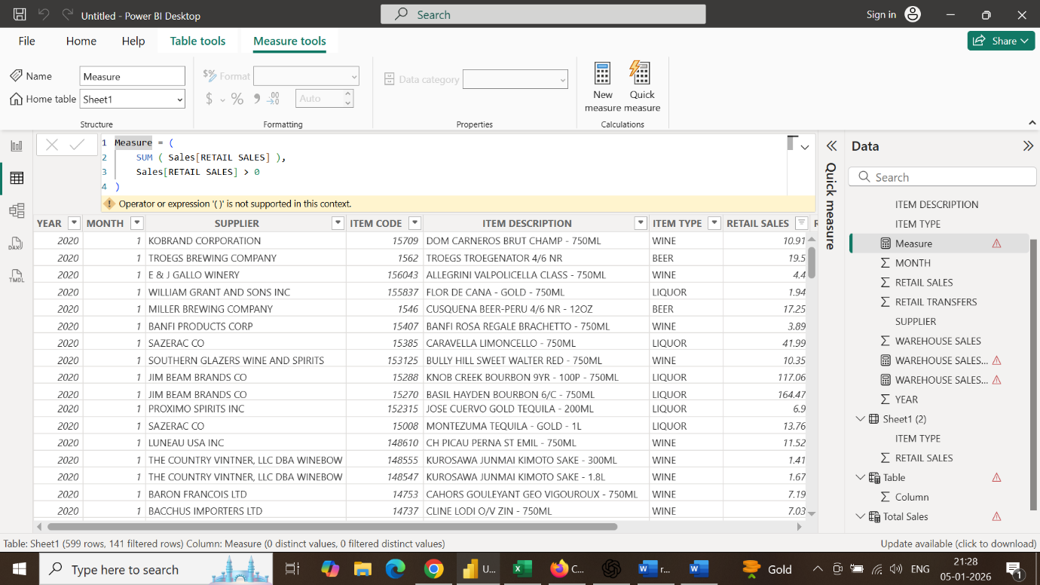

🔹 Business Impact:
This dashboard helps management:
- Track real-time sales performance
- Optimize inventory and stock movement
- Identify growth opportunities
- Make data-driven decisions for sales and distribution planning

8.Sales Transaction Attributes
Attribute | Description
Invoice / Bill No | Unique transaction number
Sales Date | Date of sale
Sales Type | Retail / Wholesale
Outlet Type | Retail Store / Warehouse
Quantity Sold | Number of units sold

9. Analysis and Visualizations (Power BI)
Dashboard Features:
• Multiple Visualizations based on problem statement: Bar charts, line charts, pie charts,
cards, and tables to communicate insights.
• Make your Report interactive Layout using Drill-down, Filters and slicers
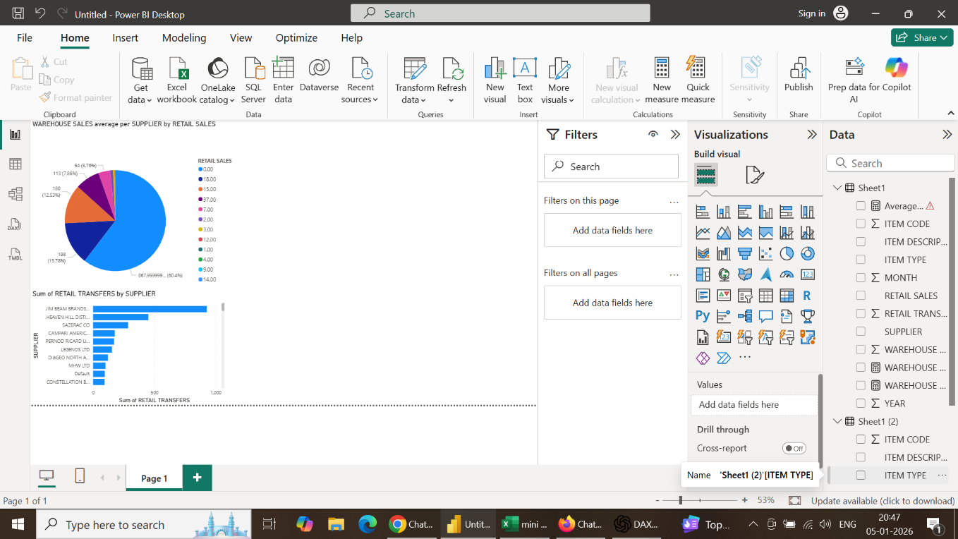
• Bookmarks, Clear Titles for each visuals & Labels is must.• Create a consolidate Report /Dashboard.
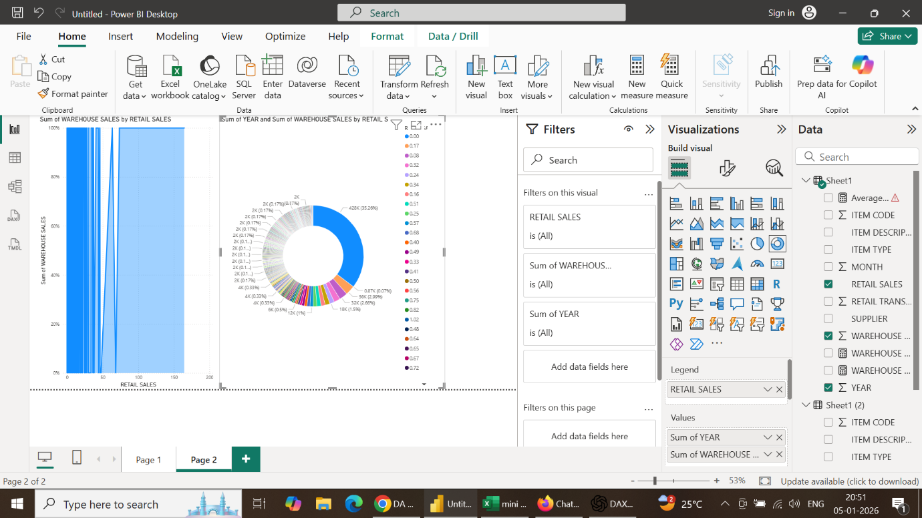

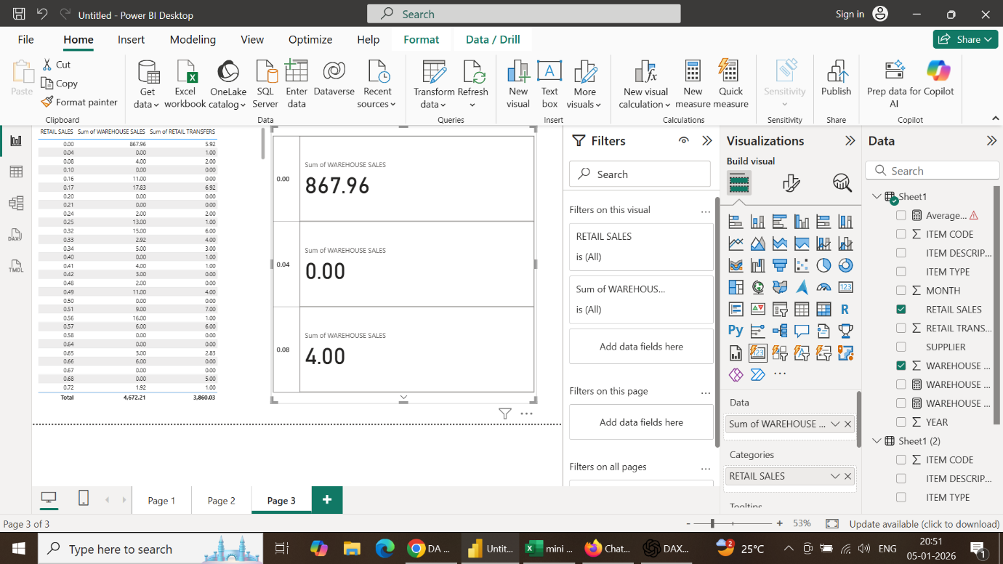

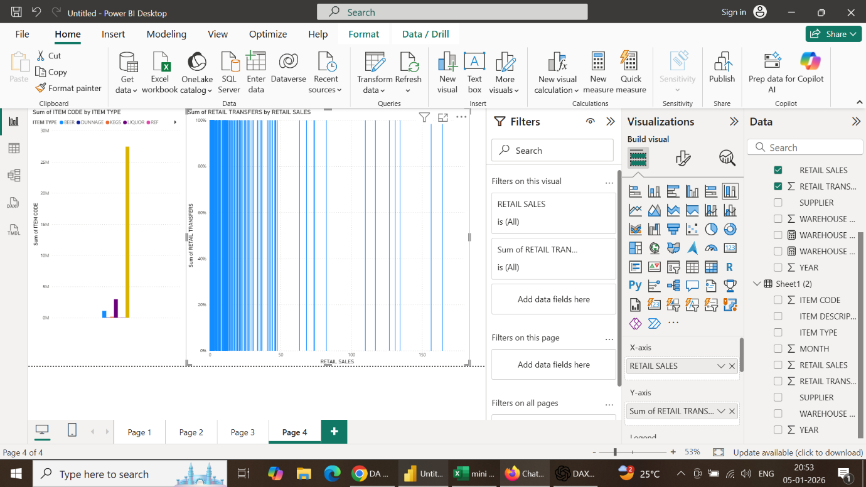

- Insights
- Warehouse sales contribute a higher volume compared to retail in several records, indicating bulk transactions and distributor-driven demand.
- Retail sales show frequent low-value transactions, reflecting walk-in customer behavior and daily consumption patterns.

- Sales Distribution Pattern
- A large number of zero values are present in both Retail and Warehouse sales, suggesting:
  - No sales days
  - Stock unavailability
  - Outlet-wise or product-wise inactivity
- Warehouse sales show occasional very high values, indicating bulk dispatches on specific days.

- Variability in Sales
- Retail sales are more consistent but smaller in value
- Warehouse sales are irregular but high in magnitude
- This highlights the need for different planning strategies for retail and warehouse operations.
- Diagnostic Analysis:
Diagnostic analysis reveals that warehouse sales spikes are due to bulk distributor orders, while zero sales indicate stock unavailability or inactive outlets.
- Prescriptive Analysis:
Prescriptive analysis suggests maintaining higher safety stock for warehouse sales during peak periods and steady replenishment for retail outlets.
- Predictive Analysis:
Predictive analysis helps estimate future sales demand based on historical retail and warehouse trends.
________________________________________________________________
10.Conclusion
The sales analysis project successfully provided a comprehensive view of retail and warehouse sales performance using Power BI and DAX measures. The analysis showed that warehouse sales contribute higher bulk revenue, while retail sales generate steady and consistent income. By separating both channels, the dashboard improved visibility into sales patterns, contribution percentages, and performance differences.

